# Add else Statement in Python

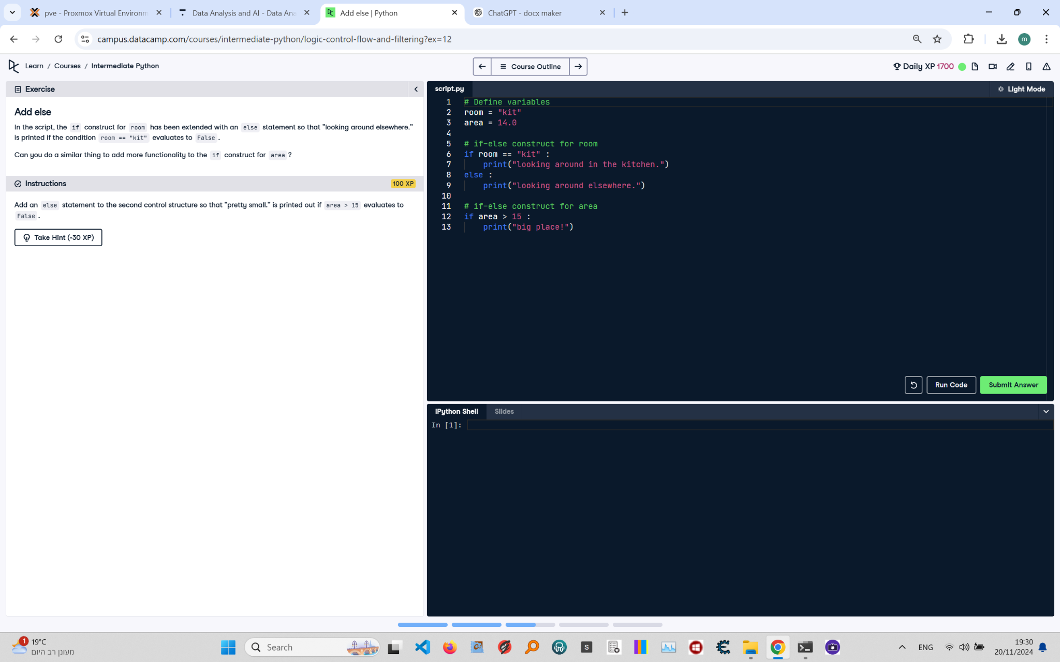

**Question:**

In the script, the `if` construct for `room` has been extended with an `else` statement so that "looking around elsewhere." is printed if the condition `room == "kit"` evaluates to `False`.  
Can you do a similar thing to add more functionality to the `if` construct for `area`?  
Add an `else` statement to the second control structure so that "pretty small." is printed out if `area > 15` evaluates to `False`.

**Answer:**

Here is the Python code that solves the problem:

# Define variables  
room = "kit"  
area = 14.0  
  
# if-else construct for room  
if room == "kit":  
 print("looking around in the kitchen.")  
else:  
 print("looking around elsewhere.")  
  
# if-else construct for area  
if area > 15:  
 print("big place!")  
else:  
 print("pretty small.")

**Explanation:**

1. **Variable Initialization**: The `room` variable is set to the string "kit" and the `area` variable is set to 14.0.  
2. **First if-else construct**: The `if` condition checks whether `room` equals "kit". If true, it prints "looking around in the kitchen." Otherwise, the `else` block executes and prints "looking around elsewhere.".  
3. **Second if-else construct**: The `if` condition checks whether `area` is greater than 15. If true, it prints "big place!". If `area` is not greater than 15, the `else` block executes and prints "pretty small.".